Instructions for paying PagoPA payment notice

Access the GOMP system https://gomp.uniroma3.it by logging into your Personal Account with the Roma3Pass credentials with which you previously registered or with the SPID, CIE (Electronic Identity Card) system.

Once logged into your Personal Account, select the Taxes and Contributions box.

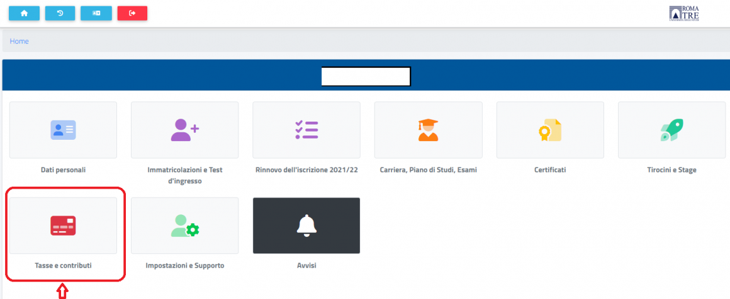

In the Taxes and Contributions screen, select the Payments box.
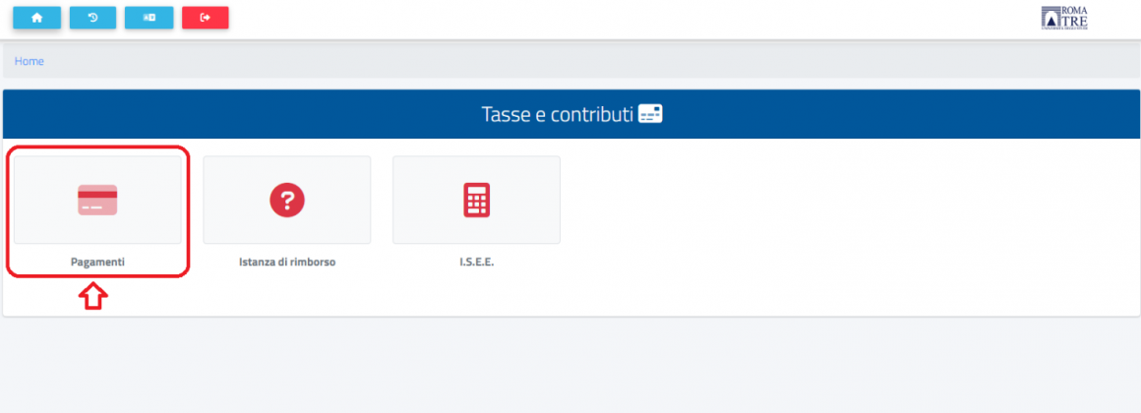

In the Payments screen, you can select online direct payment
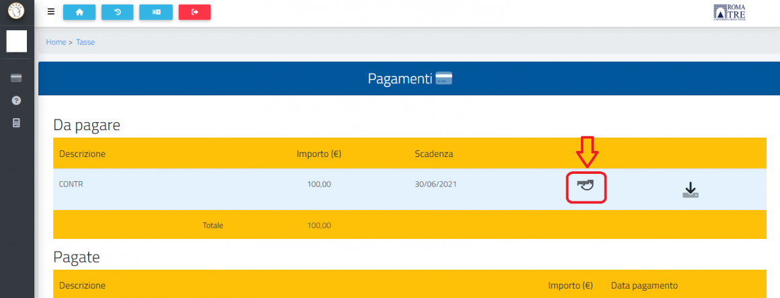
Or you can download the IUV( Identificativo Univoco di Pagamento – Unique Payment Identifier) a code assigned to a specific payment to easily identify it and pay it at one of the enabled PSP’s ( Prestatori di Servizi di Pagamento – Payment service providers) financial institutions such as banks which offer payment services.
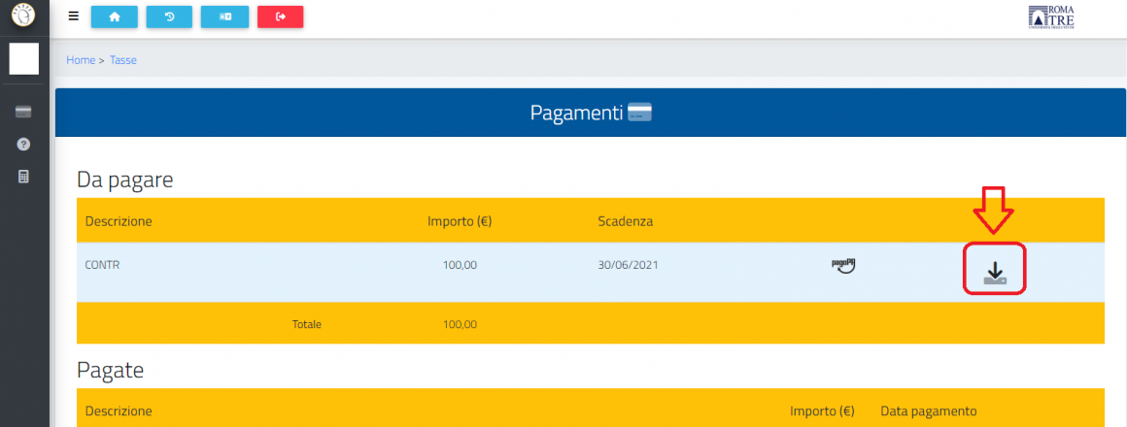
By selecting the online direct payment, you will need to access by entering the required data.
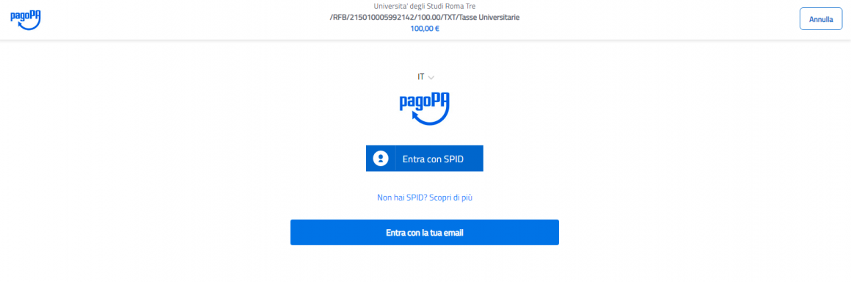
Then select your preferred payment method (e.g., Credit card, debit card, prepaid card).
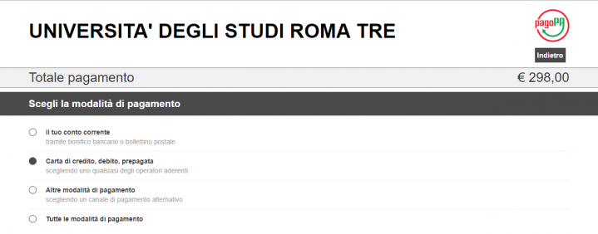
Next, choose your preferred circuit from the dropdown menu (e.g., VISA).

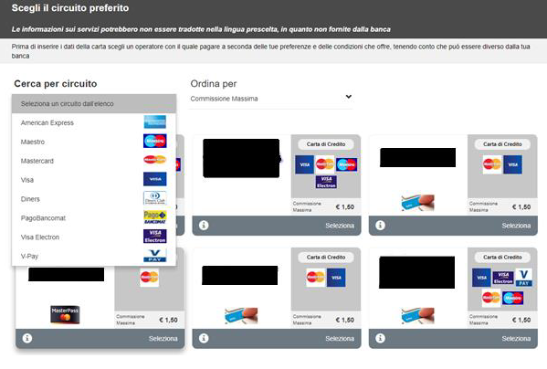

Then select the preferred Institute through which to proceed with the transaction by clicking on the Select link.

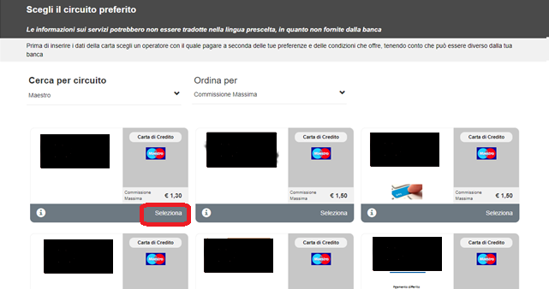
Confirm by clicking the YES button.
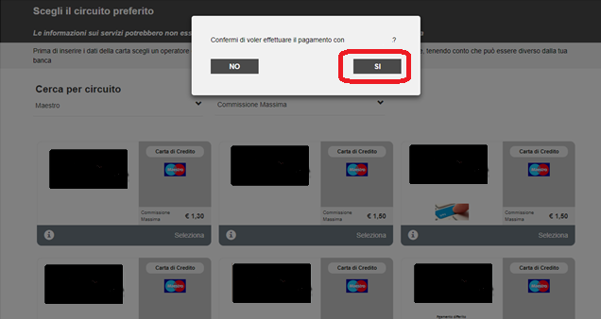
At this point, you will be redirected to the dedicated payment form of the chosen institute, where you can complete the transaction.

