How to Upload Educational Qualification Documents

Access the GOMP system at https://gomp.uniroma3.it by logging into your Students personal account using the Roma3Pass credentials you previously registered with or via the SPID system or the CIE system (Electronic Identity Card).
From the main page, select the option: ENROLMENT AND ADMISSION TEST (Immatricolazione e test d’ingresso)
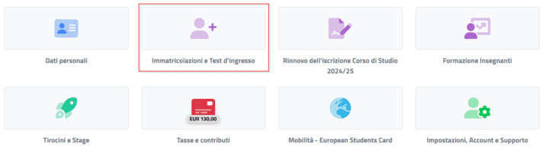

Then, depending on your needs, select one of the following options: BACHELOR’S AND SINGLE-CYCLE DEGREE COURSES or MASTER’S DEGREE COURSES. Once inside the submenu, you will find the button DECLARED ENTRY QUALIFICATIONS (Titoli di accesso dichiarati):

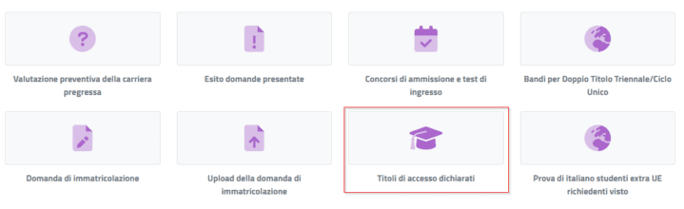
In the page, at the top right, select the OTHER ACTIONS option and click the ADD QUALIFICATION button to open the upload form:

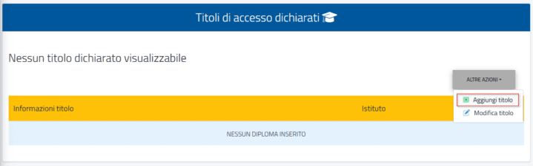
Fill in the descriptive fields and CONFIRM

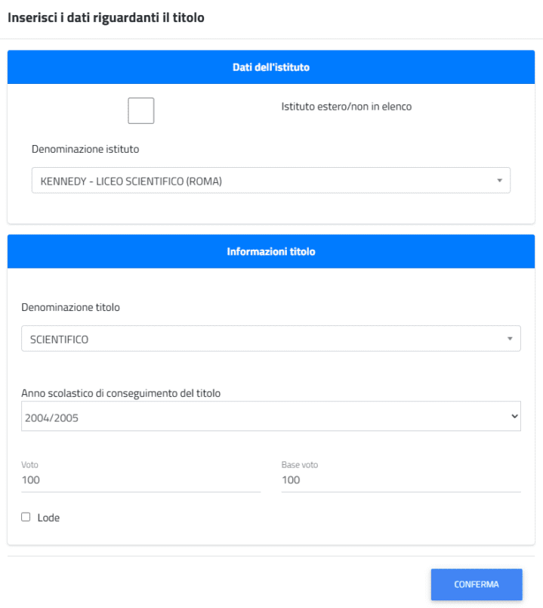
At any time, you can return to the same path and select OTHER ACTIONS – EDIT TITLE to make any necessary corrections.

